# Tutorial for levels editor

# 1st Level

## We load level base

* On the main game screen highlight **'base'**.
* Press F2 (or Edit Level) and this will open the level in editor.

Base is a suitable starting level, has several predefined items, which will save us work.

## Editor - first introduction

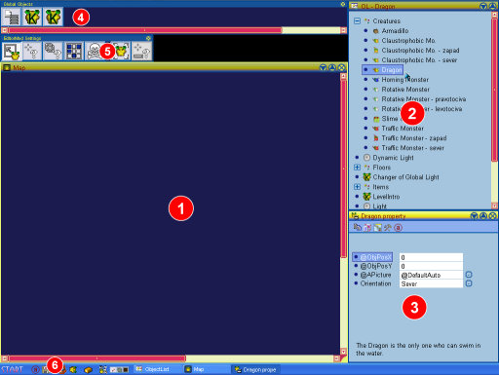

1. Map - here is where you place visible objects
2. List of objects
3. Selected object and its properties
4. Objects outside of map (invisible)
5. Editor Mode
6. Menu

## Let's get on with it

* On the list of objects (2) find Dragon (in the Creatures section) and highlight him.
* Place it on the map using the left mouse button (1).
* In the sub section Floors highlight Exit.
* Place it on the map.
* You can try other objects as well ...

## Save as

Now it is necessary to save the level under new name (we don't want to overwrite the level 'base').

* Press Ctrl+Shift+S (or on the Start menu select 'Save as').
* Enter a new name and confirm it by pressing OK.

## Let's try it

* It is necessary to have it saved; the following operation forgets unsaved changes.
* Press Shift+F2 and that will switch the editor into **game mode:**
  + You can play
  + And edit at the same time
  + Cannot be saved
* Press F2 to restart (again in game mode).
* Press Shift+F2 to restart and return to the standard editor.

# Editor controls

## Select Mode

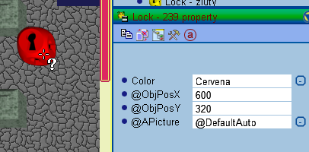

* Activation: by pressing 'S'
* Used to select already placed objects (Left button).
* Live objects properties have a **green** title. You can change these and the change will appear on the object.
* You can also easily delete the selected object by using the **Delete** key.
* Editor is unable to perform bulk highlighting or bulk property editing of multiple objects.

## Insert Mode

* It is used to copy **prototype** into the map.
* Activation (obtaining a prototype):
  + By selection from the list of objects.
  + Copying properties of an already existing object: Highlight an object (Select Mod) and press 'I'.
* **Prototype** is an auxiliary object, which we can configure as needed. It has **a yellow** title.
* We place new objects using left mouse button.
* Objects will inherit prototype properties. (By placing we create prototype’s copies.)

## Scrolling the map

* I recommend not using scrollbars.
* If the cursor is over the map and you are pressing the **space bar**, you can move the map by mouse movements.
* Map will move, when your mouse pointer reaches the screen's edge.

## Editor Modes

Main action of each mode is performed using the left mouse. Right button **deletes**.

* select_free Select - S
* 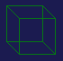 Select all on a cell - B
  + Suitable when objects overlap and common select is not enough.
  + After selecting a cell the list of all of its objects will appear.
  + Esc closes the list.
*  Insert - I
  + I - generates a prototype by copying the selected object.
  + F - same as I, but we place on coordinates **not aligned** with cell.
  + C - same as I, but we place on coordinates **aligned** with cell.
  + Activation also by selecting an object from the list of objects.
  + **Shift** while placing - places 3x3.
  + **Ctrl** while placing - deletes colliding objects.
* delete Delete - D
  + Deletes objects
  + While holding the left button, objects will be deleted only at the same level as the first deleted object (e.g. only floors).
  + **Shift** - deletes 3x3 area.
  + **Ctrl** - deletes only objects, which are of the same type as the first deleted.
* noConnect NoConnect mode - N
  + Some objects have graphics which interconnect with themselves. E.g. walls.
  + You can control graphics connections by highlighting object in this mode. Mostly you want to restrict the connections in certain directions.
* moveObj Move mode - M
  + Serves primarily to move the selected object to another location.
  + You may also move the object outside of the map or vice versa. (Outside of the map the object keeps the same coordinates, which it had on the map.)
  + **Ctrl** - deletes colliding objects.
* selectObjpointSelector Selection for an editable variable.
  + Editing some object variables occurs through "selection". This can be selection from list, selection of object type, selection of specific live object, selection of map coordinates ...
  + Esc cancels selection mode.

# Editing Object Properties

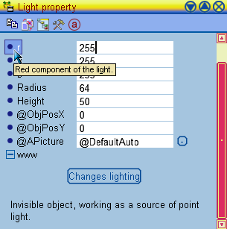

Object can have a number of editable variables, which then impact its behavior in the game. Most of the variables include **help**, which will display after keeping the cursor over the variable. Help describes significance of the variable and rules for its editing.

Variables can be of various types:

* numbers
* selection from a list of options
* link to another live object
  + it is entered by selecting an object from the map or outside of the map
  + or by selecting from the list of objects - then editor will create a new object and place it outside of the map
* object type
  + option to select same type as an object in the map
  + or select object type from the list
* coordinates on the map
* ...

Selection variables are edited by clicking the button on the right of the editing field.

Some objects require more complex editing. You may encounter custom buttons, drop down lists and similar.

## Object updates

* Changes to some variables will appear on the object instantly.
* Others require clicking an extra button.
* Others then clicking on refresh object icon.
* Variable help usually describes what needs to be done.

## Objects outside of the map (Global objects)



In a level are objects, which are not placed on the map. Editor displays these in a strip up top. These are:

* Global objects and variables, which are always present and impact the level as a whole.
* Optional global objects. If you want to use these, then select them from the object list and place them outside of the map.
* Common objects, which for now are not in the map, but some other object can place them later. This is done, because with objects outside of the map you can set their properties in great detail - hence a fully setup object will be placed.

## Important global settings

### Map size

* On the list of global objects select the Map object.
* Set map corner coordinates, these are in pixels. (One cell has 40 x 40 pixels.)
* Click the refresh button. Attention: if you are downsizing the map, then objects outside will be deleted.

### Global light

* Select the Global light object on the list of global objects.
* You can change the light's color and intensity.
* Click on the "Changes lighting" button.

### Music

* Open the Package browser  using the icon at the bottom bar.
* Find the music packs: "music.pkg" and "music2.pkg".
* Inside select a song, open its context menu and select "Set as Music to the Level".

### Setting level author and properties

* On the start menu select the item "Level Properties".

### Intro text editing

* Is edited by an external text editor.
* For a level it is necessary to create a LevelIntro.xml file.
* Specific editing rules are above the scope of this text. I recommend copying LevelIntro.xml from another level.

# Switches editing

Each switch can operate in two modes:

* **switches** - if activated a switch will perform a certain action, and in next activation it returns it back to its original state
* **does not switch** - if activated a switch will perform a certain action

If the switch places some objects onto the map, it looks, whether the target location is not already occupied by something else (whether the object collides). If the tag Don’t collide is checked, then in case of collision the object is not placed. If Don’t collide is not set, then the object will always be placed, possible colliding object will be removed from the map.

For switches, which contain a trigger (Floor Trigger, Photocell, Global Switch and so on), it is possible to set a variable Reacts. This will define when the switch is activated.

* ReagujeVzdy - reacts to turn on and to shut off
* PriZapnuti - reacts only to turn on (turn on = around the photocell you'll find objects to which it reacts)
* PriVypnuti - reacts only to turn off (turn off = there are no objects around the photocell to which it reacts)

Each switch can perform 0 to n **actions**. For each action we can independently define, what the switch will do.

## Creating an Action:

* In the Action Type variable it is necessary to select type of activity (placing, taking away, replacement...)
* In the Action Target variable it is necessary to select what the activity will be related to. There are two options. The switch can operate with already existing (created) objects. It is for example possible to create an object outside of the map, edit it and its properties and then place it back into the map later on through the game (it will be placed to those coordinates, which are entered with it). A second option is the work with an area. In this case the switch places objects of defined type into the area, or on the contrary searches objects of defined type in the area and then removes them...
* Click on the Add Action button.
* And in the end it is necessary to edit the respective action. Enter required objects or areas, enter object types and so on.

## Action types:

* PrepUmisti - Switch will fill area with a given object type. Or will place given objects.
* PrepOdeber - Switch will remove all given type objects from area. Or will remove given objects.
* PrepOdeberUmisti - Combination of the two previous actions.
* PrepVymen - A switch will find one type of objects in an area and then replace these with another type of objects. Or the switch will remove objects from the first list and replace these with objects from the second list.
* PrepMessage - defined type objects on a given area will be sent a message. Or a message will be sent to defined existing objects. If a switch switches, then it is necessary to enter two messages. One, which will be sent upon turn on, and a second, which will be sent upon shut off. Typical use is to send messages such as "TurnOn" and "TurnOff".